CPSC 4330-01/5330-01
Multimedia Processing

Instructor: Prof. JIANGJIANG (JANE) LIU

Homework 1

Andrew Kalathra
09/04/2024

Chapter 2
Projects and Problems

- 2.3*

- 2.7

* Note: For assignments, the questions are from the required textbook (info. given on syllabus) under the last section of each chapter, Projects and Problems. For example, 2.3 is the third questions about first-order entropy under "Chapter 2 Section 2.8 Projects and Problems" on Page 38.
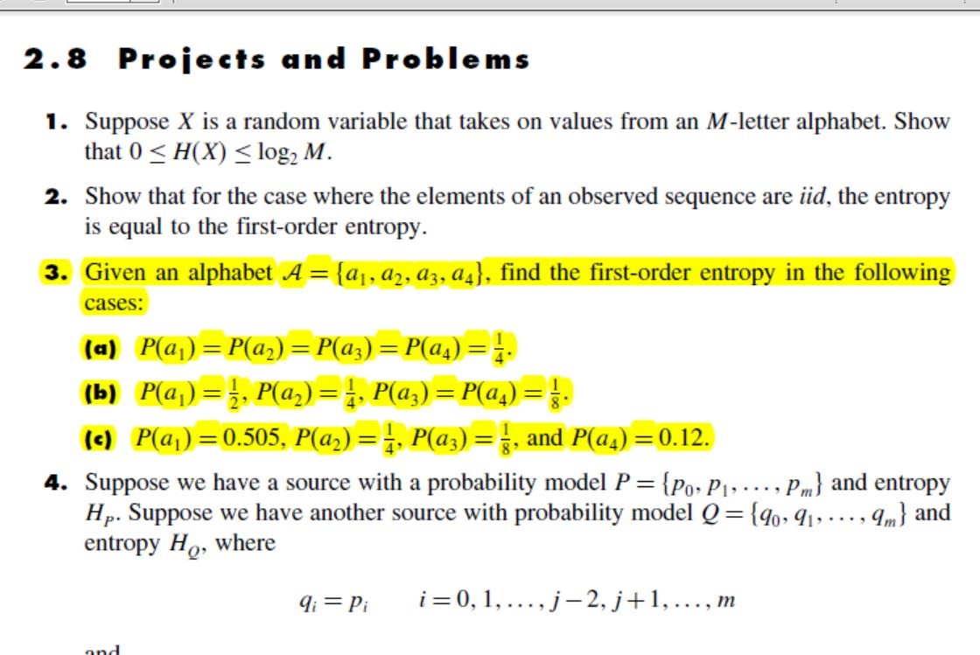

- #2.3
  - P(a₁) = P(a₂) = P(a₃) = P(a₄) = ¼
    - H = 4 * 0.25 * log₂(4)
    - H = 2
  - P(a₁) = ½ , P(a₂) = ¼ , P(a₃) = P(a₄) = 1/8
    - H = (0.5 * log₂(2) ) + (0.25 * log₂(4) ) + 2 * (0.125 * log₂(8) )
    - H = 0.5 + 0.5 + ¾
    - H = 1.75
  - P(a₁) = 0.505 , P(a₂) = ¼ , P(a₃) = 1/8 , P(a₄) = 0.12
    - H = (0.505 * log₂(1/0.505) ) + (0.25 * log₂(4) ) + (0.125 * log₂(8) ), + (0.12 * log₂(1/0.12)
    - H = (0.505 * 0.986) + (0.5) + (0.375) + (0.12 * 3.059)
    - H = 1.74

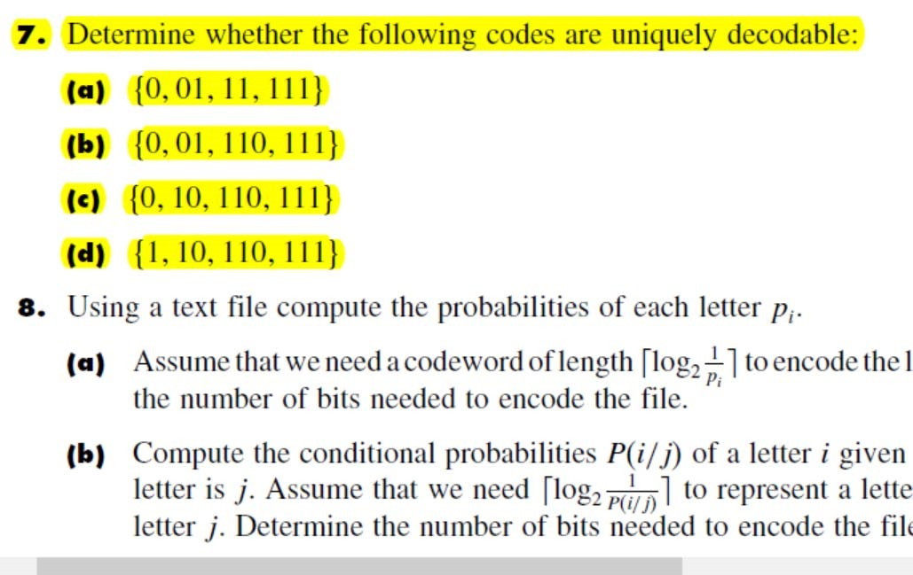

- #2.7
  - {0, 01, 11, 111}
    - Breaking this up into prefixes, we get these sets:
      - {0, 01}
      - {11, 111}
    - Examining these cases for prefixes:
      - {0, 01} 1
      - {11, 111} 1
    - Adding dangling suffix to the list: {0, 01, 11, 111, 1}
    - Examining new cases for prefixes:
      - {1, 11} 1
      - {1, 111} 11
    - Since 11 is a dangling suffix that is also a codeword, this is NOT uniquely decodable.
    - Logically: take the code 01110
      - A = 0, B = 01, C = 11, D = 111
      - ADA -or-
      - BCA -both work-
  - {0, 01, 110, 111}
    - Breaking this up into prefixes, we get these sets:
      - {0, 01}
    - Examining these cases for prefixes:
      - {0, 01} 1
    - Adding dangling suffix to the list: {0, 01, 110, 111, 1}
    - Examining new cases for prefixes:
      - {1, 110} 10
      - {1, 111} 11
    - Adding dangling suffix to the list: {0, 01, 110, 111, 1, 10, 11}
    - Examining new cases for prefixes:
      - {11, 110} 0
      - {11, 111} 1
    - Since 0 and 1 are dangling suffixes and are also codewords, this is NOT uniquely decodable.
    - Logically: take the code 01110
      - 0 = A, 01 = B, 110 = C, and 111 = D;
      - ADA -or-
      - BC -both work-
  - {0, 10, 110,111}
    - Breaking this up into prefixes, we get these sets:
      - none
    - Examining these cases for prefixes:
      - none
    - Adding dangling suffix to the list: none to add
    - Examining new cases for prefixes:
      - none
    - Since there are no dangling suffixes, we can tell this IS uniquely decodable.
  - {1, 10, 110, 111}
    - Breaking this up into prefixes, we get these sets:
      - {1, 10}
      - {1, 110}
      - {1, 111}
    - Examining these cases for prefixes:
      - {1, 10} 0
      - {1, 110} 10
      - {1, 111} 11
    - Adding dangling suffix to the list: not needed
    - Examining new cases for prefixes: not needed
    - Since 10 is a dangling suffix that is also a codeword, this is NOT uniquely decodable.
    - Logically: take the code 110
      - 1 = A, 10 = B, 110 = C, 111 = D
      - C -or-
      - AB -both work-

Requirement:
- All assignments should be typed.
- Handwritten assignments will not be accepted.
- You should have a cover page with course code, student name, date, and instructor name.

